**Startup Failure Post-Mortems 2014 First Update (6/3/2014)**

### Inq Mobile

Title: [Inq Mobile Shuts Down](http://techcrunch.com/2014/01/30/inq-mobile/)  
Title Link: <https://techcrunch.com/2014/01/30/inq-mobile/>  
Company: [Inq Mobile](https://www.cbinsights.com/company/inq-moblie)  
Company Link: <https://www.cbinsights.com/company/inq-moblie>

Inq has been a really exciting business over the last few years and whilst there have been significant successes, the technology that’s been borne out of that work has been identified to have greater application within the wider Group. Consequently, we’ve taken the hard decision to close the Inq business down.

# Inq Moblie

CONSUMER PRODUCTS & SERVICES | Consumer Electronics  
[inqmobile.com](https://inqmobile.com/)

## Founded Year

1999

## Stage

Dead | Dead

## About Inq Moblie

Inq Moblie is a smartphone-maker, creating a range of devices that included two 'Facebook phones' in 2011.

## Inq Moblie Headquarter Location

30501 Agoura Road Suite 203

Agoura Hills, California, 91301,

United States

# **Inq Mobile, One Of The First Facebook Phone Makers, Shuts Down**

**[Catherine Shu](https://techcrunch.com/author/catherine-shu/)**[@catherineshu](https://twitter.com/catherineshu) / 7:18 AM GMT+1•January 31, 2014  
Title Link: <https://techcrunch.com/2014/01/30/inq-mobile/>

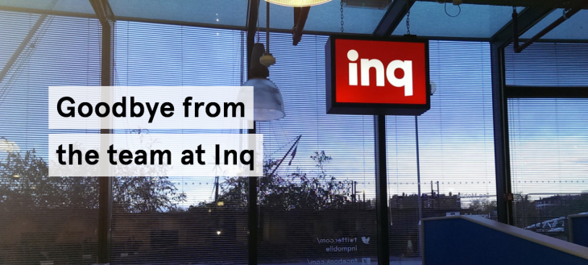

Inq Mobile, one of [the first companies to build a Facebook phone](https://beta.techcrunch.com/2011/02/09/video-inq-facebook-phone/), announced that it has shut down with a message on its site (h/t [Android Police](http://www.androidpolice.com/2014/01/30/uk-based-inq-mobile-quietly-shuts-down-remaining-apps-will-not-be-updated/)). In a statement, the U.K.-based, [Hutchison Whampoa](http://www.hutchison-whampoa.com/en/global/home.php)-backed company said:

“Inq has been a really exciting business over the last few years and whilst there have been significant successes, the technology that’s been borne out of that work has been identified to have greater application within the wider Hutchison group. Consequently, we’ve taken the hard decision to close the Inq business down.

We want to thank all the customers and employees that have engaged with Inq’s products and experiences over the years.

Inq’s software services Material and SO.HO will be closed down at the end of January. For more information please go to www.inqmobile.com.”

Inq, which was founded in 2008 and pivoted a year ago to focus on mobile software, said it will no longer update Material and SO.HO, its apps. Material, a news reader, released its final editions on Jan. 28, while social media aggregator SO.HO will not be updated after today, though it will continue to function. Support pages for the Cloud Touch smartphone and Inq’s featurephones remain on its site.

The timing of Inq’s closure and Material’s shutdown is interesting because [several of tech’s largest companies have recently started to offer their own news apps and tools](http://mediagazer.com/140129/p37). These include [Yahoo’s News Digest](https://beta.techcrunch.com/2014/01/07/yahoo-launches-news-digest-its-first-app-based-on-summly/); Twitter and CNN’s [Dataminr](https://beta.techcrunch.com/2014/01/29/dataminr-for-news); and [Paper by Facebook](https://beta.techcrunch.com/2014/01/30/facebook-paper/), which will launch next month.

Inq Mobile began as a maker of low-priced Android smartphones. It was [one of the first companies that collaborated with Facebook to create a social smartphone](https://www.brighthand.com/default.asp?newsID=17064&news=Facebook+phone+smartphone+social+networking) in 2011, around the same time HTC and the social network struck the partnership that yielded the [Salsa](https://beta.techcrunch.com/2011/07/25/the-htc-statussalsa-facebook-phone-lands-in-china-as-the-htc-weike-sina-weibo-phone/) and [ChaCha](https://beta.techcrunch.com/2011/06/20/social-addicts-rejoice-htc-chacha-facebook-phone-headed-for-att/).

Inq’s Cloud Touch, which was released exclusively in the UK three years ago, had a custom Facebook wrapper built on top of Android, and an early version of SwiftKey. Though cheaply priced (starting at $50 with a subsidized contract), the Cloud Touch couldn’t compete with Samsung’s rapid takeover of the Android market. The company pivoted and started developing mobile apps one year ago.

Material, which [TechCrunch covered when it launched its iOS version in August](https://beta.techcrunch.com/2013/08/28/inq-material-ios/), was a social magazine app that used Inq’s “interest extraction engine” to look at the Facebook and Twitter accounts of users and figure out what kind of articles they wanted to see. Content was delivered in two daily editions.

At its launch, Material already had strong competition from popular social news readers like [Flipboard](http://www.flipboard.com/), [Zite](http://zite.com/), and [Pulse](https://www.pulse.me/).

Inq CEO and co-founder Ken Johnstone told TechCrunch at the time that Material differentiated from other news readers by offering an easier set-up than its rivals because all users needed to do to power Material’s algorithms was connect their Facebook or Twitter accounts.

“For somebody who has invested a lot of time in Twitter and Facebook anyway, this is about getting a return on that investment,” Johnstone told TechCrunch’s Natasha Lomas.

Yahoo, Twitter, and Facebook’s news aggregation products all feature some human curation, but, like Material, they also rely heavily on algorithms to customize content for each user. Inq had planned to monetize Material by harvesting enough data to build an advertising business, but its failure to do may be a cautionary tale for other developers of news readers, even as they [continue to rethink how content is organized](https://beta.techcrunch.com/2014/01/29/flipboard-mimics-magazines-further-with-a-shift-to-structured-content-revamped-cover-stories/).

Though algorithms are necessary if a news aggregator wants to scale up (and collect enough data to be profitable), they still can’t replace the discernment of a human editor. Like Feedly, Pulse, and Zite, Material’s customized content stream suffered from problems like miscategorized stories, irrelevant content, and “the overall feeling you get from flicking through an edition is not a cohesive, editorially unified whole, but an algorithmically generated bunch of mostly random stories with (at best) a few loose, overlapping themes,” as Natasha put it.